P250/1
Geography
PHYSICAL GEOGRAPHY
Paper 1
Jul. /Aug. 2019
3 Hours

JOINT MOCK EXAMINATIONS, 2019
Uganda Advanced Certificate of Education
GEOGRAPHY
Paper 1
PHYSICAL GEOGRAPHY
3 hours

INSTRUCTIONS TO CANDIDATES:
- Answer four questions in all: Section A is compulsory. At least one question should be answered from section B and one question from section C.

- Credit will be given for the use of relevant sketch maps, diagrams and specific examples studied in the field.

- Any additional question(s) answered will not be marked.

Turn Over
SECTION A:
COMPULSORY MAPWORK AND PHOTOGRAPHY INTERPRETATION
Choose two questions from this section.

- COMPULSORY MAP WORK QUESTION:
Study the 1:50,000 (UGANDA) MASINDI map extract and answer the questions that follow.
- (i) State the grid reference of the road junction at Bujenje. (01 mark)
(ii) Name the physical feature found at grid reference 545915. (01 mark)

- (i) Measure the distance of the all-weather loose surface road from the road junction at
Masindi grid reference 570872 Atura in the North East. (01 mark)
(ii) Calculate the amplitude of the area covered by the map of Masindi. (02 marks)

- Given the new scale of the map of Masindi is 1:125,000.
- Calculate the reduction factor. (02 marks)
- Use the reduction factor calculated in c(i) above and draw a reduced sketch map of the area covered by the map and on it mark and name
- Any two physical regions
- Any four land use activities
- Any two drainage features. (09marks)

- Describe the relief of the area covered by the map.

- Describe the relationship between
- relief and land use
- drainage and vegetation
- COMPULSORY PHOTOGRAPH QUESTIONS
Study the photograph provided and answer the questions that follow.

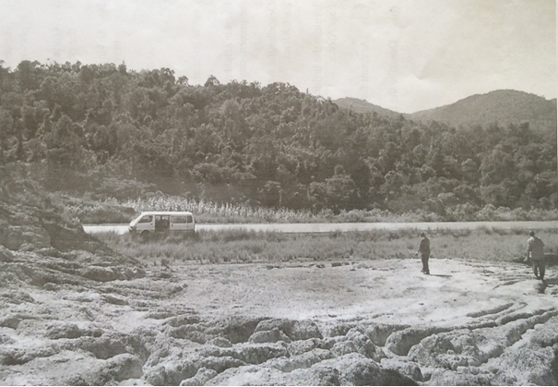
- Draw a landscape sketch of the area covered by the photograph and on it mark and name:
- any three relief features
- any three land use activities. (09 marks)
- Describe the relationship between relief and land use in the area covered by the photograph. (06 marks)

- Giving evidence from the photograph, explain the problems faced by the people living in the area. (08 marks)

- Giving reasons to support your answer, suggest one area in East Africa where the photograph was taken. (02 marks)
SECTION B
GEOMORPHOLOGY
Attempt one question from this section
- (a) What is continental drift? (05 marks)
(b) Examine the relevance of Wegener’s continental drift theory. (20 marks)

- Examine the influence of tectonism on the development of lakes in East Africa.(25 marks)

- Describe the processes leading to the formation of wave erosional landforms. (25 marks)

SECTION C
CLIMATE, NATURAL VEGETATION AND SOIL
Attempt one question from this section.

- (a) Differentiate between weather and climate. (05 marks)
(b) Describe the factors influencing the distribution of rainfall in East Africa. (20 marks)

- (a) Describe the characteristics of Ocean currents. (10 marks)
(b) Describe the effects of Ocean currents on the climate of surrounding areas.
(15 marks)

- To what extent have human activities influenced vegetation zonation in East Africa?
(25 marks)

End

